BioOntology Project Tutorial

BioOntology is short for Automated Ontology Generation Framework Powered by Linked Biomedical Ontology. BioOntology is novel framework that integrates various natural language processing, semantic enrichment, syntactic pattern, and graph algorithm based techniques. Moreover, it shows that using Linked Biomedical Ontologies (LBO) enables a promising solution to the problem of automating the process of ontology generation. This tutorial focuses on the various choices you have for installing and run BioOntology framework. You can find BioOntology here:

https://github.com/bmwhi5/BioOnto

This BioOntology tutorial consists two parts as following:

* Installation
* Running the framework

Please cite the following papers if you use BioOntology tools:

1. Alobaidi, M., Malik, K. M., & Hussain, M. (2018). Automated ontology generation framework powered by linked biomedical ontologies for disease-drug domain. *Computer methods and programs in biomedicine*, *165*, 117-128.
2. Alobaidi, M., Malik, K. M., & Sabra, S. (2018). Linked open data-based framework for automatic biomedical ontology generation. *BMC bioinformatics*, *19*(1), 319.

Installation

In order to "install" and "run" BioOntology in your environment you need to do the following:

1. Installing Eclipse ID (tested with KEPLER)
2. Installing Java SDK 1.8.0 or later
3. Downloading BioOntology from Github
4. Importing BioOntology framework project in Eclipse IDE
5. Downloading dependency JARs
   1. A zip file called "Vendor" can be found in the same site of the project in Github
6. Adding dependency JARs files to your Classpath application
7. Installing MetaMap server ( if you want to use UMLS mapping )
   1. https://metamap.nlm.nih.gov/JavaApi.shtml

Running

1) Run the mainView class as java application from Eclipse. Figure 1 shows the app start dialog.

To extract non-hierarchy relations of the discovered concepts

To extract synonyms of the discovered concepts

To extract titles from PubMed repository

To extract hierarchies of the discovered concepts

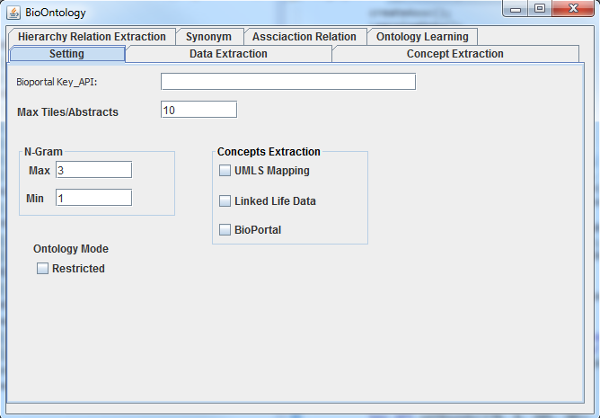

Concepts extraction

Bioportal key_API

The number of titles the will be extracted in Data Extraction tab

Set the methods that the framework uses

Figure 1.

Not used yet

To set the min & max window size for N-gram Method that the framework uses